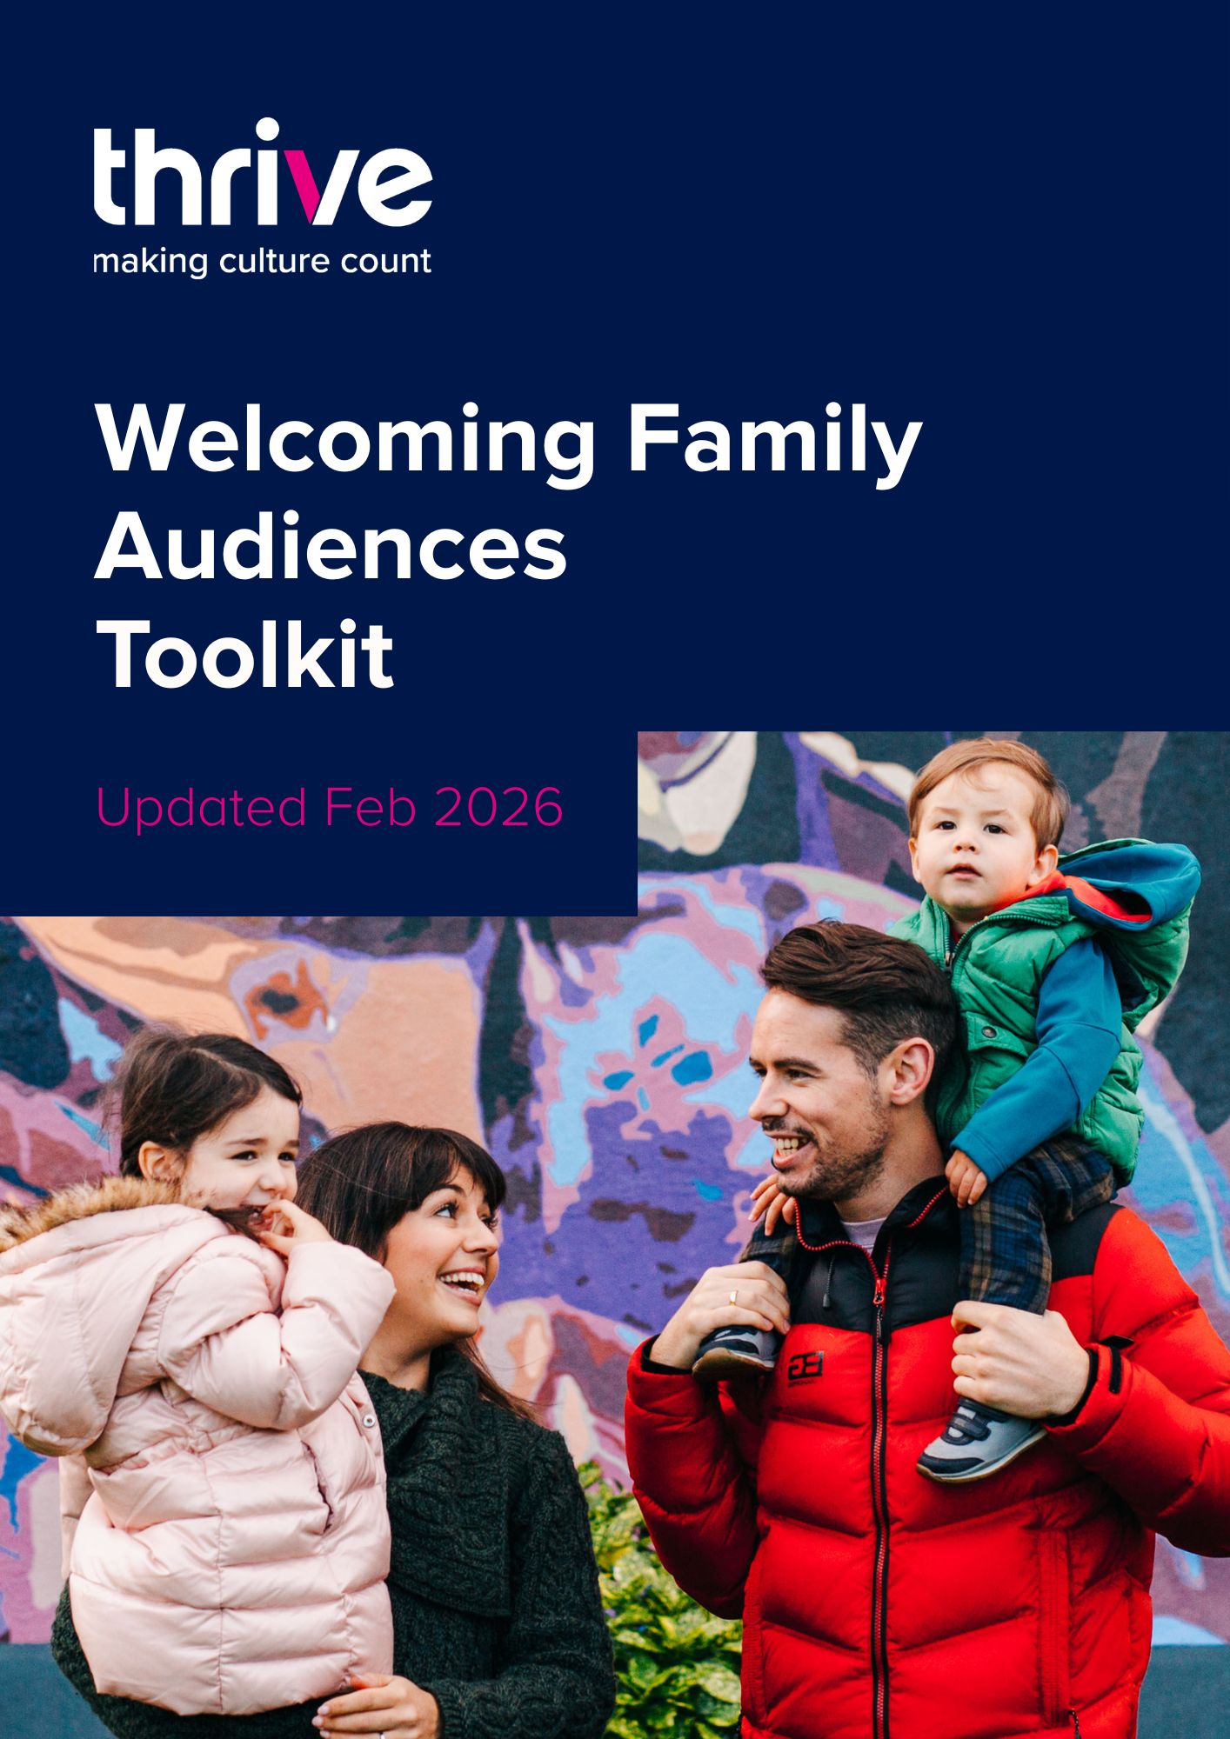
About this guide
This guide will take you through some elements you should consider when engaging with family audiences. We’ve included some case studies too, so that you can see a few family-focused arts organisations in action and get some inspiration!
We’ve split the guide into 5 steps, which cover the following areas:
- Programming
- Accessibility
- Creating a Family Friendly Experience
- Pricing For Family Audiences
- Marketing and Communications
At the end of the guide, we have a checklist summarising the key points of each section.
About thrive
We’re Thrive - the research and evaluation people for arts and heritage.
We uncover the real relationship between art, policy, people and place. Our work doesn’t just capture numbers, it helps organisations and policymakers understand what those numbers mean and how to act on them. We created IMPACT, the first research of its kind to show who really attends the arts in Northern Ireland, and how that attendance brings economic and social value.
We offer accessible, practical help - whether free or budget-friendly - across research, evaluation, and marketing. Our team knows Northern Irish audiences inside out, and we’re here to share that knowledge to drive real change in the sector. Because we believe that the future of arts and heritage depends on strong relationships with people. And the people here? They’re not like anywhere else. What makes us different?
- We’re the only audience development organisation on the island of Ireland
We have 20 years of experience and we’re here on the ground working in our sector. We pride ourselves on delivering practical support - we won’t just hand you a report and leave it at that.
- We know research and we know the sector
We carry out surveys, focus groups, observational research, interviews and ticketing analysis. We don’t just work with performing arts venues; our research is inclusive of heritage, non-ticketed and participatory projects. As a not for profit organisation funded by the Arts Council of Northern Ireland, we can offer support that’s more affordable than commercial consultancies because we’re part of this sector, just like you.
What we know about Family Audiences: Context from our IMPACT Research
IMPACT is a sector-wide, post-visit audience survey that tells us who is attending arts and culture across Northern Ireland. It also gives us insight into their motivations, barriers and behaviours.
It has shown us that family audiences behave differently to other audience segments.
Those motivations, behaviours and barriers are different for families, and you should keep this in mind when engaging with them. Only 9% of arts audiences we surveyed went to an arts event with children aged 11 and younger, and only 6% attended with children aged 12-18. This suggests they’re underrepresented in “traditional” arts spaces.
Families are also key to building future engagement. If a child experiences your venue or artform when they’re young, they’re likely to have more confidence to explore the arts again when they’re older.
Motivations: Quality Time
IMPACT tells us that families choose to attend because they want to spend time with the people they care about, keep their kids entertained, and feel part of a community.
Families want their visit to be real quality time. Make sure what you offer is fun for children and engaging for parents, with plenty of chances for them to connect and enjoy moments together.
Their experience doesn’t just happen inside your venue. IMPACT shows that families feel excited before they arrive and leave feeling happy, proud, and even a little in awe. Tap into that energy: encourage them to share their pre‑visit excitement on your social media, and invite them to leave reviews afterwards.
IMPACT also shows that visitors with children are far more likely to be new audiences. Families often have very limited time, and parents juggle a lot of responsibilities— so choosing activities can feel like a big decision. This can make them cautious about where they go. If they choose your venue, they want the visit to be worthwhile and well worth the effort of planning and travelling.
Once they walk through your doors, it’s your chance to wow them. A great first impression can turn a first‑time family into repeat visitors. Make arrivals friendly and smooth, and make sure your staff are welcoming, confident with families, and genuinely enthusiastic.
Behaviours and Barriers
IMPACT tells us that family audiences also behave differently to other audiences.
They’re more likely to live hyper-locally, with journey times of 15 minutes or less. Factor this into your marketing strategy – concentrate your efforts locally first. When it's time to reach further afield, be sure to include 'getting here' information with social posts.
Family audiences are less engaged on average, meaning they go to arts and culture events less frequently throughout the year. Not just with your specific venue, but across the board. If they are choosing you, it is a big deal - so treat them accordingly.
And think about how you are going to continue to build that relationship – don't lose any opportunity to ask them to come back and visit you again. You could consider family-focused loyalty schemes or a family specific newsletter to keep the conversation going.
They’re late bookers too – possibly because there are a lot of moving parts to organising a family visit. Things can change last minute, children get sick, other commitments pop up – family bookers want to feel certain they can make it before they book. Incentivising earlier booking through early bird offers could be a good option. Offering refunds will also ease worries about plans changing and losing their money.

Family audiences are more likely to be acutely impacted by the rising cost-of-living – they're more likely to attend less often and to spend less when they do attend. Offering cost-saving options could be a good strategy to alleviate this – and that doesn’t mean dropping your ticket prices and calling it a day! Offering flexible discounts and concessions is a good option, as well as allowing families to bring their own food and drink (more on this in our Pricing and Accessibility sections). It doesn’t always have to be cheaper tickets – adding little perks to make parents’ lives easier can also show them you’re considering their needs. This can go a long way in building their trust in your venue/space. Maybe offer a free cup of coffee for parents, or free sweets at the interval for the kids.

Section 1: Programming for Family Audiences
If you’re hoping to develop an offer for family audiences, step one is to do your market research and find out what's already happening for them in your local area. Identify gaps in the market and areas that are already saturated – and don’t stop at arts organisations. What time do the local youth football clubs practice on a Saturday? Does the local library already have a story hour on a Sunday morning?
You can reach out to other organisations (arts or otherwise) and coordinate with them to avoid clashes or identify collaborative opportunities. Have a look at websites/directories that highlight family friendly events too, such as NI4kids.
Long story short, find the gaps and think about what (if anything) your organisation can do to fill them. Get specific with your target audience - interests and skills change rapidly as children grow, so different age groups will need different experiences. Don’t spread yourself too thin – pick something you can do well, with a suitable audience in mind.
Before you dive into creating something brand new, look at your existing programming – is there anything you can make family friendly?
If you’ve settled on programming something new for families, the sky is the limit. A 2018 report from ArtsConnect shows that children aged 10 – 19 have a very wide-ranging idea of ‘culture’, so don’t make the mistake of thinking certain artforms can’t be kid-friendly with the right approach. Belfast Children’s Festival have done some brilliant work across a range of artforms, even some that might not typically be considered family-friendly.

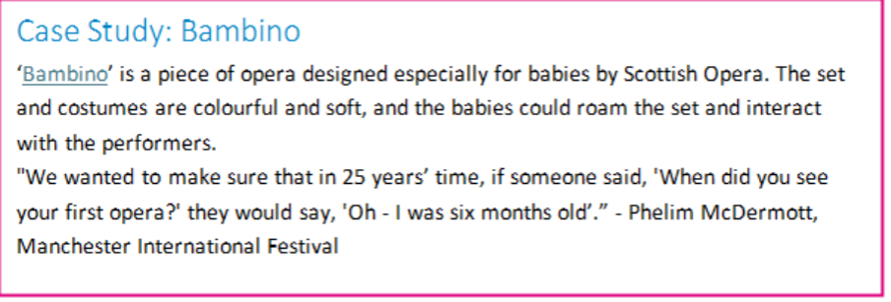
Section 2. Accessibility for Families

Your venue/space should be accessible to as many families as possible.

Every family is different and it’s important to welcome children and parents with diverse needs. Not every organisation can provide the same access measures, but you should let family audiences know what you do offer. They will need to know what they can expect if they’re attending with a d/Deaf or Disabled child (or as a d/Deaf/Disabled parent).

Be mindful of the marketing of your accessible performances. Though there may be extra measures in place to accommodate audiences with different needs and preferences, accessible shows are still suitable for all audiences. Relaxed or accessible performances can and should be just as high quality as the rest of your programming. Marketing them separately to the rest of your programming could send a negative message.

When it comes to communicating what accessibility measures you have in place, broad statements aren’t helpful to parents – get specific! Don’t label your space as ‘fully accessible’- this is practically impossible, and doesn’t actually help visitors decide if the space meets their specific needs. Outline what measures you have in place i.e.. Step-free access, accessible all-gender changing rooms, BSL/ISL interpreters. Providing plenty of information will allow people to decide whether your space is accessible their children. If part of your building or space is not accessible, let visitors know about this beforehand.

Social Narrative Videos

A social narrative video is a video that lets visitors know what to expect when they visit your venue/space. They can include a walkthrough of your space, guidance on how to get there, parking and public transport information, guidance on who to approach for help when they arrive, and information about what accessibility provisions are in place (and how to access them).

The Waterfront and the Ulster Hall in Belfast have some great examples on their accessibility web page here.

Make your website and booking process accessible

Your website and all online materials should be built with accessibility in mind – make sure they’re screen-reader friendly and use accessible fonts and colours. Charity Digital have some guidance on this here.

The booking process for wheelchair friendly/accessible seating or carer’s tickets shouldn’t be more complicated than your usual booking process. Make sure these options are easily accessible on the booking page. If wheelchair users/carers will need support from a staff member when they arrive to get to their seats, clearly indicate this at the point of purchase too.

A dedicated page on your organisation’s website that details what your organisation is doing to be more accessible, and what people can expect when they visit, can be very helpful to anyone planning to attend, but especially parents. The Millennium Forum theatre have a good example of this here.

Relaxed Performances

Many children may not enjoy the ‘traditional’ experience of sitting still in a dark theatre. Relaxed performances are a great way to make theatre more accessible to a wider range of children, some of whom may have differing needs or preferences. Relaxed Performances can involve technical changes to the show itself (quieter music, soft lighting/lights remaining on for the duration) or changes to the venue guidelines (audience members are free to move around, laugh, dance, and come and go as they please). Whatever measures you put in place to make your performances relaxed, make sure you communicate them clearly online and that you late visitors know what to expect. Touretteshero have a great FAQ about relaxed performances here.

Case Study: The Esplanade Theatre

The Esplanade Theatre offers the following as part of their relaxed performances:

- Flexible seating - Families can choose where and how they’d like to sit, whether it’s on the floor, on cushions, or in chairs.
- Gentle lighting - The auditorium is never pitch-dark, so children can still see their surroundings and feel safe.
- Free to move/make noise -No one is asked to stay silent or still. Children can laugh, dance or respond freely.
- Families can come and go as needed.
- Actors are part of the experience. They often acknowledge the audience’s reactions, creating a two-wy interaction that feels natural and inclusive.

Other accessibility measures you can offer include:

- BSL/ISL interpretation for performances
- Quiet/sensory room available for people with sensory needs (clearly signposted if available)
- Audio loop system for people who are d/Deaf or hard of hearing
- Clear online booking process for wheelchairs/accessible seating and carer’s/essential companion tickets
- Changing Places/accessible toilets (clearly signposted if available)
- If you’re a festival, prioritise working with accessible venues and communicate their accessibility information with your bookers
- Offer ear defenders or fidget toys for attendees with sensory needs
- Ensure your website/online brochure is accessible for those using screen readers.
- Use image descriptions on photos and captions on videos posted on your website or social media channels

Section 3. Creating A Family Friendly Visitor Experience
IMPACT tells us that quality time is a big motivator for family audiences, so it's important to provide a high quality, engaging experience when they visit your venue or space.
Set the Tone
Make it as clear as possible that your space is family friendly as soon as visitors walk in. Comfy seating and chill-out zones let people know they’re free to linger or take a rest. Buggy parking and cloakrooms (clearly signposted) can literally lighten the load for parents and caregivers.
Welcoming, enthusiastic staff can be your biggest asset in creating a memorable visit. If you have a big family event coming up, choose staff who have experience and love working with kids. Keep staff well informed of what provisions you have available for families (ideas for these provisions will be included in our accessibility section)– having a crib sheet or Family FAQs document available for staff can be handy.
Take a child’s eye view of your venue and consider whether kids and their families will feel welcomed and engaged throughout the stages of their visit. Lockers, ticket desks, bins, doorways are often at eye level for children, and these can all be transformed into something fun and engaging by adding interactive or tactile elements.
For older age groups, wifi, music, food and social spaces are key to engaging young people in having enjoyable experiences with their family and friends.
Case Study: The Postal Museum
London’s Postal Museum hosts interactive exhibits detailing the history of the UK’s postal service. There’s lots for young audiences to interact with, including riding the ‘mail rail’ train, and they have specific spaces/activities dedicated to under 8s and under 5s that can be booked in addition to museum entry or on their own. For the under 5s, they have their Sorted! Experience- a 45 minute play session in an immersive mini town with post-themed activities. This a great way for parent and child to learn about the museum’s subject matter together – and have a bit of fun too. They have a lovely video of some of the activities here.

Be mindful of the rules/restrictions of your venue and how you communicate them. If you have a no-latecomers policy, consider waiving it for family shows or offering complimentary tickets to another performance if a family arrives too late.
If there are rules about making noise/moving around the venue/space during an event, consider whether these could exclude people attending with children, and whether you could relax them for family-friendly events.
Food and Drink
Allowing families to bring their own food/drink into your space is the most accessible option. It can remove cost barriers, as well as making life easier for those bringing children with dietary needs. If this is something you can offer, make it clear to parents ahead of their visit. Offer free drinking water and the option to heat up baby food in microwaves if you can. If there’s any specific types of food that aren’t permitted, communicate this clearly on your website/socials.
Creating an outdoor picnic area or designated indoor areas where families can sit and eat, allows families to save money by bringing their own food – and also takes care of any worries about fussy eaters.
If you have food and drink available for purchase on-site, there should be kid-friendly and healthy options available where possible. You should also share menus and prices online so that families can plan their spend and ensure there are options suitable for their child. If your venue/space has blanket policies around food or drink, consider whether these can be tweaked to be more accessible to families.
Kids In Museums have put together a list of standards to consider when making a café family friendly. Have a read here.
Be Baby-Friendly
Make it clear that breastfeeding is welcome, and provide suitable seating for this. Any business open to the public can join the ‘Breastfeeding Welcome Here’ scheme. You’ll get a sticker and certificate to display, and you’ll be listed on their website too.
Providing free baby wipes or nappies in your bathrooms doesn’t have to be too expensive, but can make a massive difference to a parent in need.

Age Suitability Guidelines
Give parents clear information about whether the show is suitable for their child but try not to get too prescriptive with this. If you’re producing a show or event, why not invite some children of different age groups in to try it out and see how they respond.
Let parents know how age guidelines were decided. Clearly communicate whether any age restrictions are suggested or if they’re enforced at the door. Getting too strict with age guidelines can exclude kids who would love to engage with you. For example, if a kid’s show with some scary moments is recommended for children 7 and older, that could be suitable for some 6-year-olds, but also too overwhelming for some 8-year-olds. Providing extra information around age suitability can equip parents to make the right decisions for their kids.
Film classifications are a good guide to follow – they offer an age rating, some basic information on what’s in the film, and a link to further information/trailers. Have a look here.
Section 4: Pricing For Family Audiences
In 2025, we carried out Pricing Research with arts organisations across Northern Ireland, representing a wide range of artforms. This gave us valuable insight into how ticket prices are set and how family ticketing is currently approached.
A large majority of organisations offering family tickets still use a standard “2 adults, 2 children” model. While familiar, this structure is not inclusive. It can exclude families with more or fewer children, as well as lone-parent families. Introducing more flexible family ticket options can make your organisation significantly more financially accessible.
We also found that 59% of surveyed organisations offer discounted child tickets, but the age cut-off for these tickets varies widely. Some set the limit at age 12, others at 13–16, and some up to 18. Most organisations do not charge for babies, with the typical cut-off for a free baby ticket being around age 2. Parents may prefer child tickets because they offer more flexibility than fixed-price family packages, but clear communication around age limits is crucial to avoid confusion.
Overall, clear, visible information is essential for removing cost as a barrier. Make sure your ticket prices, discount options, group deals, and any cost-saving offers are clearly explained and easy for parents to find on your website.
Does free mean free?
When it comes to free events and experiences, a free ticket doesn’t equal a free day out for families. The average IMPACT respondent had an ancillary spend of £54, across things like food, drink and transport.
There are other ways to ease the cost-pressure of attending an event that your organisation can consider. We mentioned earlier that allowing families to bring their own food and drink can make attending far more accessible. Providing a picnic space so that families can bring their own refreshments is a good idea too. Having designated areas for eating and drinking helps with the clean up too!
Some venues allow ticket-buyers to pre-purchase snacks and souvenirs along with pantomime tickets – so that families can see the full cost before they get there. Share all your food/merch prices with bookers ahead of time so they can plan what they’ll spend.

Section 5: Marketing Your Organisation to Families
Parents need information up-front: they want all their questions answered, quickly, and clearly. It’s better to be specific, as missing information may lead to a bad visitor experience, or they may decide not to bother coming at all.
Children’s needs and tastes vary massively from one child to the next, so providing as much information as possible allows parents to make their own decisions about whether an event/space is suitable for their child.
When you’re proofreading copy for a family event, check whether you’ve answered the following questions:
- What are the discounts/concessions available for families?
- What specific age range is it suitable for? Is this a recommendation, or is it enforced on the door?
- What is the show duration? When are interval and end times?
- What is the latecomer policy (and have you considered families when setting it)?
- Are children welcome to make noise?
- Will they get messy? Do they need a change of clothes?
- Will they have anything to bring home with them afterwards?
- Where is the nearest parking available and what public transport options are there?
- Are there accessible bathroom and changing facilities for all genders?
- Can you bring your own food and drink? If not, what food is available and what are the prices?
- What accessibility provisions are available for d/Deaf or Disabled parents and children?
- Is it possible to heat up baby food and bottles?
- Is there a buggy carpark?
- Are all spaces accessible for wheelchairs or buggies?
If this feels like too much to include in one post, making a screen-reader compatible FAQ infographic or including a link to a dedicated FAQ or Accessibility page on your website, could be possible alternatives.
Speak their language
Make sure your copy is appropriate for the event. Copy for families tends to be lighter than usual, but don’t forget it’s likely that adults will be the people reading it, so don’t overdo it on the baby-talk! Research has shown that parents are more active on social media than non-parents, and that mothers are more active than fathers. Are your own social media profiles engaging and interesting for parents, and for mums in particular?

Case Study: Z-Café’s Building Information
Z-Café is the UK’s only dedicated arts centre for children and families, and they have lots of information on their website about what to expect when you get there, all delivered in a parent-friendly tone. Their building information page includes guidance on what accessibility provisions are available and how to ask for them, information about companion tickets, and their latecomers policy (spoiler alert, they welcome latecomers for kids shows!) You can have a read through the full page here.

Word-of-mouth is incredibly important for families. IMPACT shows that the main channels that family audiences hear about events through are word-of-mouth and Facebook. Develop your Facebook presence, with specific attention paid to local family audiences. IMPACT tells us they’re hyperlocal, and want to feel part of a community. Reach out to existing community Facebook pages to collaborate. Consider collaborations with local businesses ie. Pre-show family dinner or discounts at a local ice cream shop.
The most important thing you can do is to really wow your family audiences, and create a first-class visitor experience. Once you’ve done this, create channels for families to share their experiences – encourage them to leave reviews, or you could share responses from post-event surveys.

Check List
Programming
☐ Do your market research – find out what’s out there and how you can fit in
☐ Review your existing programming to see what can be made family friendly
☐ If you’re creating something new, remember that family-friendliness isn’t artform specific – be imaginative!
Accessibility
☐ Ensure that the process for booking accessible/wheelchair-friendly/carer’s tickets is straightforward
☐ Make sure that your website and online materials are screen-reader friendly and use accessible fonts and colours
☐ Create a dedicated accessibility page on your website
☐ Offer social narrative videos to let people know what to expect when visiting your space
☐ Offer relaxed performances to make shows more accessible to a wider range of children with different needs/preferences
Creating a Family Friendly Experience
☐ Prioritise quality time for families – offer opportunities for connection between parents and their kids throughout their visit
☐ Welcome breastfeeding parents
☐ Incorporate interactive/tactile elements into your space at eye-level for kids
☐ Allow families to bring their own food/drink and/or create an outdoor picnic area if possible
☐ If you have a café, offer kid-friendly and healthy options. Make menus and prices available online
☐ List performance times and intervals online. Offer a relaxed latecomer policy for families.
☐List age suitability online and communicate whether it’s a restriction or a suggestion
☐ Enlist enthusiastic, confident staff who enjoy working with kids
☐ Ensure easy access and storage for wheelchairs and buggies
☐ Offer free wifi and water
☐ Offer clearly signposted, family-friendly bathrooms with changing facilities for all genders where possible
Pricing/Ticketing
☐ Offer discounted child tickets rather than set family tickets
☐ Offer refunds or early bird discounts to offset late booking trends
☐ Offer multi-buy discounts or family-focused loyalty schemes to offset low engagement (visiting less frequently)
☐ Clearly communicate age cutoffs for child tickets
☐ Ensure all cost-saving options, group deals and discounts are easy to find on your website
☐ Make bookers aware of ancillary costs (food/drink/merchandise) by sharing them clearly on your website so they can plan what they’ll spend
Marketing
☐ Make sure your copy is relaxed and friendly, suitable for parents and their kids
☐ Provide as much information about the event as possible, or link to an FAQ web page, to help parents make decisions
☐ Prioritise Facebook and local communities in your marketing – family audiences are hyperlocal and community oriented
☐ Encourage family audiences to share their experience by leaving reviews or posting online

More Support
If you’d like some one-to-one support to increase or diversify your family audiences, you can book in for a Free Advice Session. We also conduct research projects and create audience development strategies for a wide range of organisations. Check out our How We Can Help page to find out more.

Further Resources

The Family Arts Campaign has lots of great resources on how best to include family audiences in your space. Check out their Family Arts Standards too
www.familyarts.co.uk

Baker Richards has some great UK-wide research on emerging trends among family audiences: https://baker-richards.com/understanding-the-family-visitor-market-insights-from-new-research/

The Audience Agency has a great blog series about how ‘family-friendly’ and ‘baby-friendly' aren’t always the same: https://theaudienceagency.org/en/news/learning-diaries-we-got-you-babe-part-1

Young at Art has a great page on their website where they share the accessibility provisions available at their shows:
http://www.youngatart.co.uk/access

Next Atlas has a helpful article about emerging trends to keep in mind that are influencing parents and families: https://blog.nextatlas.com/article/modern-parenting-trends-family-life-behavior

British Film Institute has great guidelines for engaging with different age groups within their younger audiences: https://www.bfi-fan.org.uk/wp-content/uploads/2025/03/FAN-Young-Audience-Info-Pack.pdf

